THE PAUL R. TRIVETT
BURSARY PROGRAM

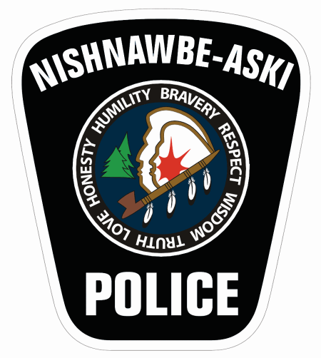

Application Criteria

June, 2013

Paul Russell Trivett

Chief Paul Trivett joined the Nishnawbe-Aski Police Service in 2005 as the Deputy Chief of Police and later became the Chief for the organization.

He served as a constable with Georgina Island Police from 1981 to 1986. He joined the OPP in 1986 to 2005 working in various capacities and locations.
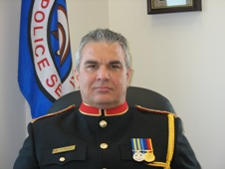
He had twenty-five years of experience in community-based policing, primarily in the service of Aboriginal communities. Paul had received national recognition for his commitment to teach others about First Nations issues and cultures and has been the recipient of the Ontario Bicentennial Medal for “Outstanding Volunteer Service to Community” and the Ontario Amethyst Award for “Excellence in Public Service”.

He had received two OPP Commissioners Citations for Lifesaving and an “Award of Excellence” from the Canadian Professional Police Association for ice and water rescue. His passion for the development of strategies for youth empowerment and healthy lifestyles made him a dynamic role model for youth.

When Chief Paul Trivett became Chief of Police of Nishnawbe-Aski Police Service in January of 2006, he helped to further realign a police service that had many challenges organizationally, geographically and financially.

He had lectured extensively to the police community, the public sector and government bodies throughout Canada on a wide variety of First Nations police-related matters.

Chief Trivett was a member of the Canadian First Nations Chiefs of Police Association, and was very active and influential with that platform.

Moreover, Chief Trivett actively visited and participated in forums in the north. He worked earnestly at youth issues, and always reworked his schedule for youth initiatives. Chief Trivett coached hockey and soccer for over thirty years in the communities that he was a police officer.

Paul has had the responsibilities of a pipe carrier in his community and in the greater Aboriginal community as well. In doing so he has made a commitment to live and teach the meaning of tradition from the Ojibway perspective. He was extremely well respected and admired.

We honour his contributions to the Service with the Scholarship Fund in his memory. Paul was very committed to youth and education. The Police Service Board hosts an annual Golf Tournament that funds the Scholarship. Other staff activities also contribute to the Fund such as Dress Down Days, and the NAPSWEAR clothing line.
PAUL TRIVETT MEMORIAL BURSARY PROGRAM
Application Criteria

The Nishnawbe-Aski Police Service Board has been very active in raising money for the Paul Trivett Memorial Scholarship Fund and would like to expand the scope of the fund to include all members of the Nishnawbe Aski Nation. We propose to do this by awarding bursaries through this fund.

Eligibility Requirements
You are eligible to apply for the bursary if you meet the following two (2) requirements:
- Acceptance and enrollment in an accredited college, university or vocational institution.
- You are a member of NAN (a copy of your status card or letterhead from your First Nation stating that you are a member will be sufficient for proof of eligibility).

Application Requirements
Preference will be given to:
- Students who have enrolled in studies related to policing and/or law;
- Students enrolled in full time studies;
- First year students; and,
- First time applicants who have not received this bursary in the past.
**The committee may also take into consideration the demonstrated need for financial assistance and the academic record of the applicant(s) to determine the successful recipients.

The Bursary Program
There will be a minimum of four $500 bursaries awarded for a total of $2000 annually to be made available from the fund. The Scholarship Committee reserves the right to increase or decrease the number of bursaries awarded and/or the amount of each bursary depending upon funds available and the number of applications received.
Application Requirements:
A letter must be sent to: NAPS Headquarters Attn: Kelly Reid
c/o Paul Trivett Memorial Scholarship Fund
309 Court Street South, Thunder Bay, ON P7B 2Y1

The letter shall include, but not be limited to, the following:
- Applicant’s contact information (phone number, email address and/or mailing address);
- Letter of Acceptance from the accredited College or University indicating the program you are enrolled in;
- Education and career goals;
- Demonstrate the need for financial assistance; and,
- Copies of recent academic records.

Subsequent calls for additional applicants may be allowed if there is a shortage of applicants.

Scholarship Committee
- The Committee is made up of at least three members who will oversee the application review and award process. At least one representative from the Police Service Board shall participate as a committee member.
- The committee has the authority to make modifications and changes it deems necessary to ensure that the process is completed in a timely and cost efficient manner. Any changes shall be instituted as policy where necessary and the policy shall be updated on an annual basis.
- Notification of the selected candidates will be forwarded to the Board for record keeping purposes. The Board reserves the right to publicly announce the award recipients.
Application Deadline: June 30, 2013

